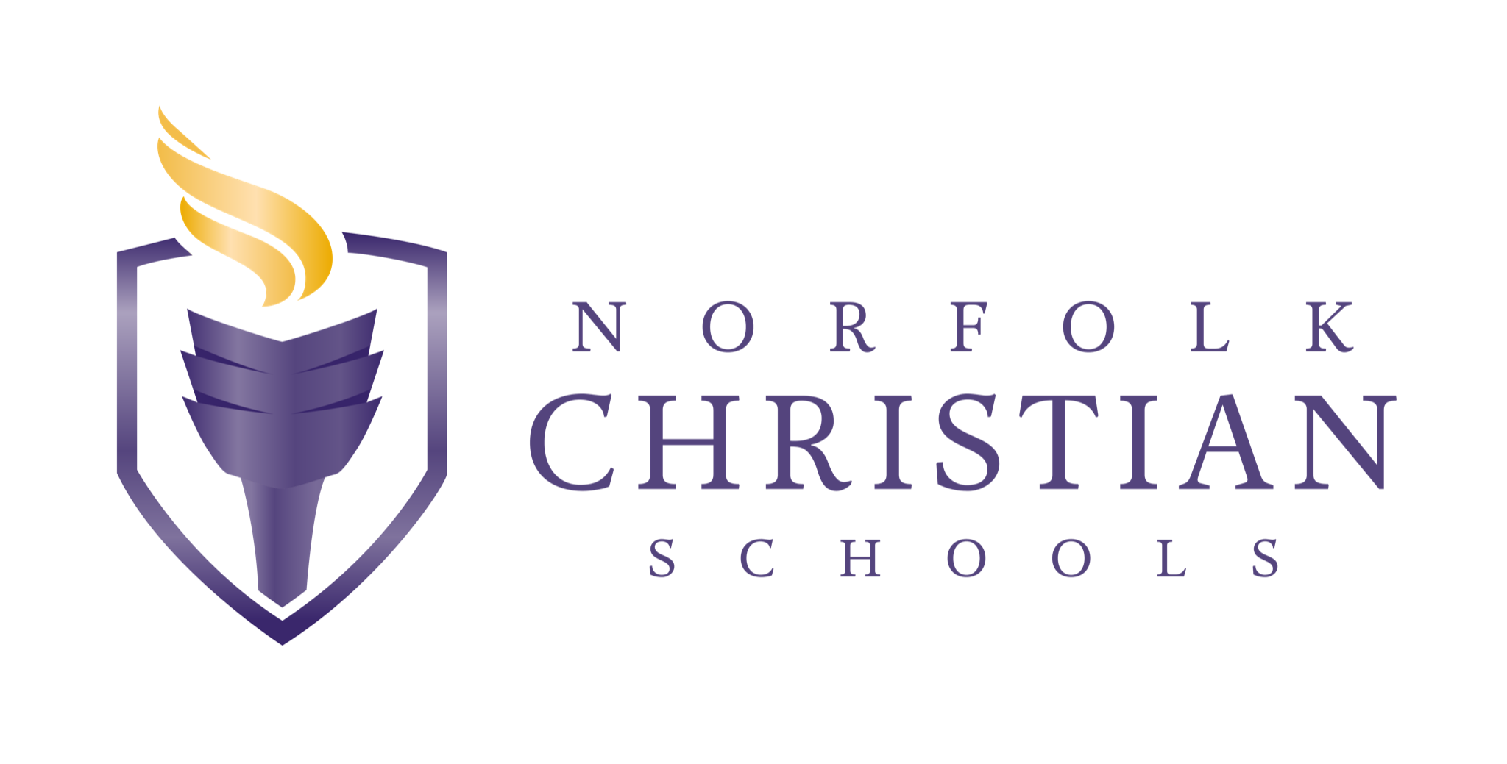

JOB DESCRIPTION

Job Title: Custodian

Campus: Upper School

Reports to: Facilities Director
Status: Full-time (M-F 10:00p-6:00a)

Job Summary
The custodial team will maintain cleanliness, order, and safety of the Upper School campus. The position involves a variety of tasks to ensure that the school environment remains clean, hygienic, and conducive to learning.

Responsibilities
- Cleaning and Sanitizing: Custodians will be responsible for cleaning and sanitizing classrooms, hallways, restrooms, cafeteria, gymnasium, and other areas within the school. This includes sweeping, mopping, vacuuming, dusting, and disinfecting surfaces.
- Waste Management: Custodians handle waste disposal, including emptying trash cans, recycling bins, and disposing of garbage in a proper manner. They may also assist in sorting and recycling materials.
- Maintenance and Repairs: Custodians perform basic maintenance tasks such as changing light bulbs and fixing minor equipment problems. They will report any major maintenance needs to the facilities director.
- Safety and Security: Custodian will play a role in maintaining a safe environment by ensuring that exits, stairways, and pathways are clear and accessible. They will also help in ensuring that all doors are locked for the safety of our students and staff.
- Stocking and Inventory: Custodians will notify Facilities Director of cleaning supplies, equipment, and inventory levels to ensure availability when needed.
- Event Support: Custodians may assist with setting up and cleaning up after school events, meetings, and other gatherings.
- Collaboration and Communication: Custodians work collaboratively with teachers, staff, and administrators to address cleaning needs and communicate any issues or concerns related to the school's maintenance and cleanliness.

Qualifications
- Experience: Previous experience in custodial or janitorial work is beneficial, especially in a school or similar setting. Familiarity with cleaning techniques, equipment, and safety protocols is valuable.
- Knowledge of Cleaning Procedures: Understanding various cleaning procedures, including sanitizing, disinfecting, and maintaining cleanliness in different areas of the school, such as classrooms, restrooms, hallways, and common areas.
- Attention to Detail: A keen eye for detail and the ability to maintain a high standard of cleanliness throughout the school environment. This includes ensuring floors are properly cleaned, surfaces are dust-free, and trash is properly disposed of.
- Time Management: Being able to effectively manage time and prioritize tasks to ensure all cleaning duties are completed within designated timeframes.
- Physical Stamina: The role of a custodian can involve physical activities such as lifting heavy objects, moving furniture, and standing or walking for extended periods. Good physical stamina and the ability to perform these tasks safely are important.
- Communication Skills: Effective communication skills are necessary to collaborate with colleagues, teachers, and other staff members. Clear communication helps address any specific cleaning needs or concerns.
- Safety Awareness: Knowledge of safety protocols and the ability to adhere to them to create a safe environment for students, staff, and visitors. This includes proper handling and storage of cleaning chemicals and understanding emergency procedures.
- Flexibility: Being adaptable to different cleaning needs and schedules, as custodial work may involve occasional evening or weekend shifts, especially during events or maintenance projects.

